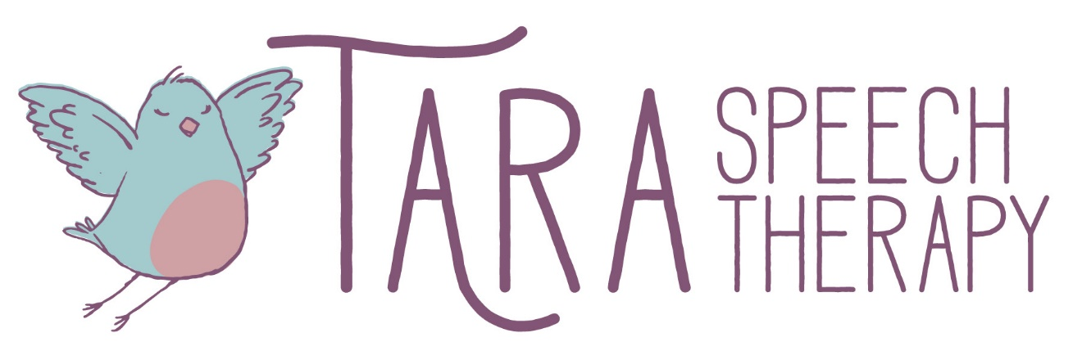
Language Development Norms
1 2 M O N T H S
- Understands up to 10 words
- Understands simple directions
- Uses first true word
- Turns head to sound of their name
- Vocalizes or gestures wants + needs
- Babbles with varied sounds, (no, bye, hot, etc.) paired w/ gestures (sit, give etc.) volume and intonation
1 8 M O N T H S
- In the single word phase from 12-18 months
- Uses 50 words at 18 months
- Typically uses single words for attribution, action, location, existence, nonexistence, denial, rejection, recurrence and position before moving on to 2 words
- Enters the 2 word stage between 18 and 24 months
2 4 M O N T H S
- Uses 2 word sentences 50% and Uses 3-4 word sentences 50% the time
- 2 words to express the following relations: noticing, nomination, instrumental, conjunction, recurrence, action-object, agent-action, possessor-possession, attribute-entity, entity + location, action + location etc
- Morpheme:"-ing" (19-28 months)
3 6 M O N T H S
- Asks wh- questions 200-600 words at 30 months
- Understands up to 3,600 words
- Asks wh- questions
- Morphemes by months in age: "in" + "on at 36 months (27-30); plural s (24-33); irregular past tense (25-46); possessive s (26-40); the uncontractible copula (27-29)
Speech Development
I N T E L L I G I B I L I T Y T O A F A M I L I A R L I S T E N E R
- 18 months: 25%
- 24 months: 50%
- 36 months: 75%
- 48 months: 100%
A G E O F M A S T E R Y
- 2-3 years: m, n, p, b, t, d, h, w, y
-Words should have beginning and ending sounds.
-If you notice a tongue thrust (tongue protrudes from his mouth on sounds other than “th” –most commonly seen on s, t, z and ch), this is a difficult habit to break and should be addressed immediately.
- 4 years: k, g, f, ng
- 5 years: r, l, s, sh, th, z, dg, ch, zh, v and all r, l and s blends

Brown’s Morpehmes:
